Assignment:-2

**Sample table1: salesman**

Create Table Salesman

(salesman_id int Primary Key,

name nvarchar(20) not null,

city nvarchar(20) not null,

commission float not null)

insert into salesman values(11,'Kairav','Karwar',0.13)

insert into salesman values(24,'Hiren','Bengalore',0.11)

insert into salesman values(39,'Krishna','Kodagu',0.12)

insert into salesman values(44,'Kiara','Hubli',0.15)

insert into salesman values(15,'Harsh','Mysore',0.11)

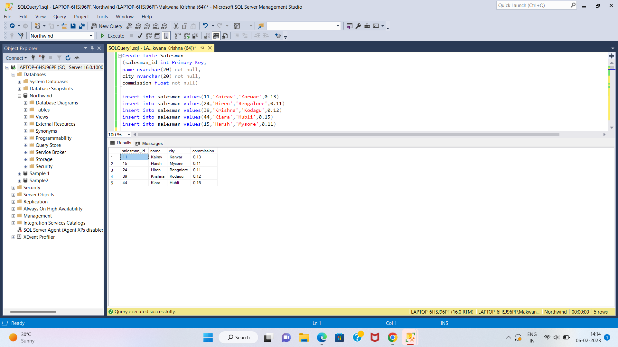

**Sample table2: customer**

create table customer

(customer_id int primary key,

cust_name varchar(20) not null,

city varchar(20) not null,

grade int not null,

salesman_id int references salesman(salesman_id) on delete set null);

insert into customer values(101,'Bhargav','Mysore',1,15);

insert into customer values(206,'Ramya','Bengalore',3,24);

insert into customer values(225,'Rajesh','Hubli',2,39);

insert into customer values(324,'Ravi','Mangalore',5,44);

insert into customer values(456,'Rajdeep','Belagavi',3,15);

insert into customer values(501,'Raghu','Dharavad',4,39);

insert into customer values(300,'Bhavya','Bengalore',1,15);

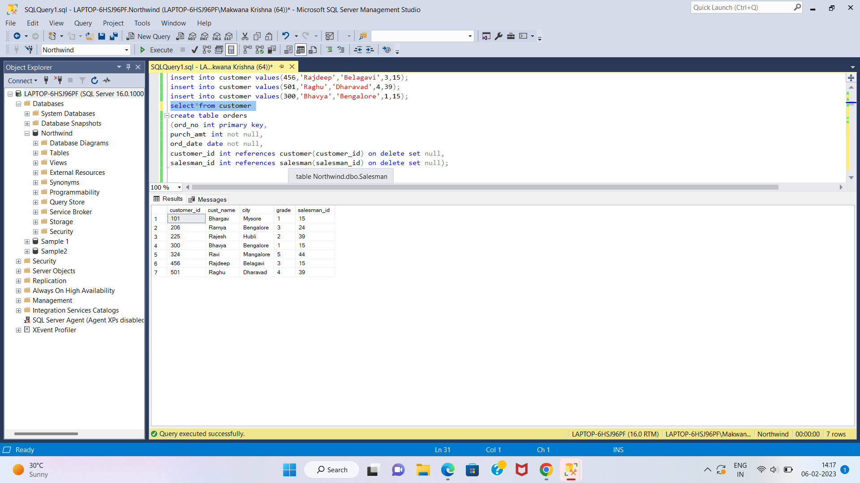

**Sample table3: orders**

create table orders

(ord_no int primary key,

purch_amt int not null,

ord_date date not null,

customer_id int references customer(customer_id) on delete set null,

salesman_id int references salesman(salesman_id) on delete set null);

insert into orders values(5,10000, '2020-03-25' ,101,11);

insert into orders values(10,5000,'2020-03-25',456,15);

insert into orders values(7,9500, '2020-04-03',225,44);

insert into orders values(11,8700,'2020-07-07',324,24);

insert into orders values(17,1500,'2020-07-07', 206,39);

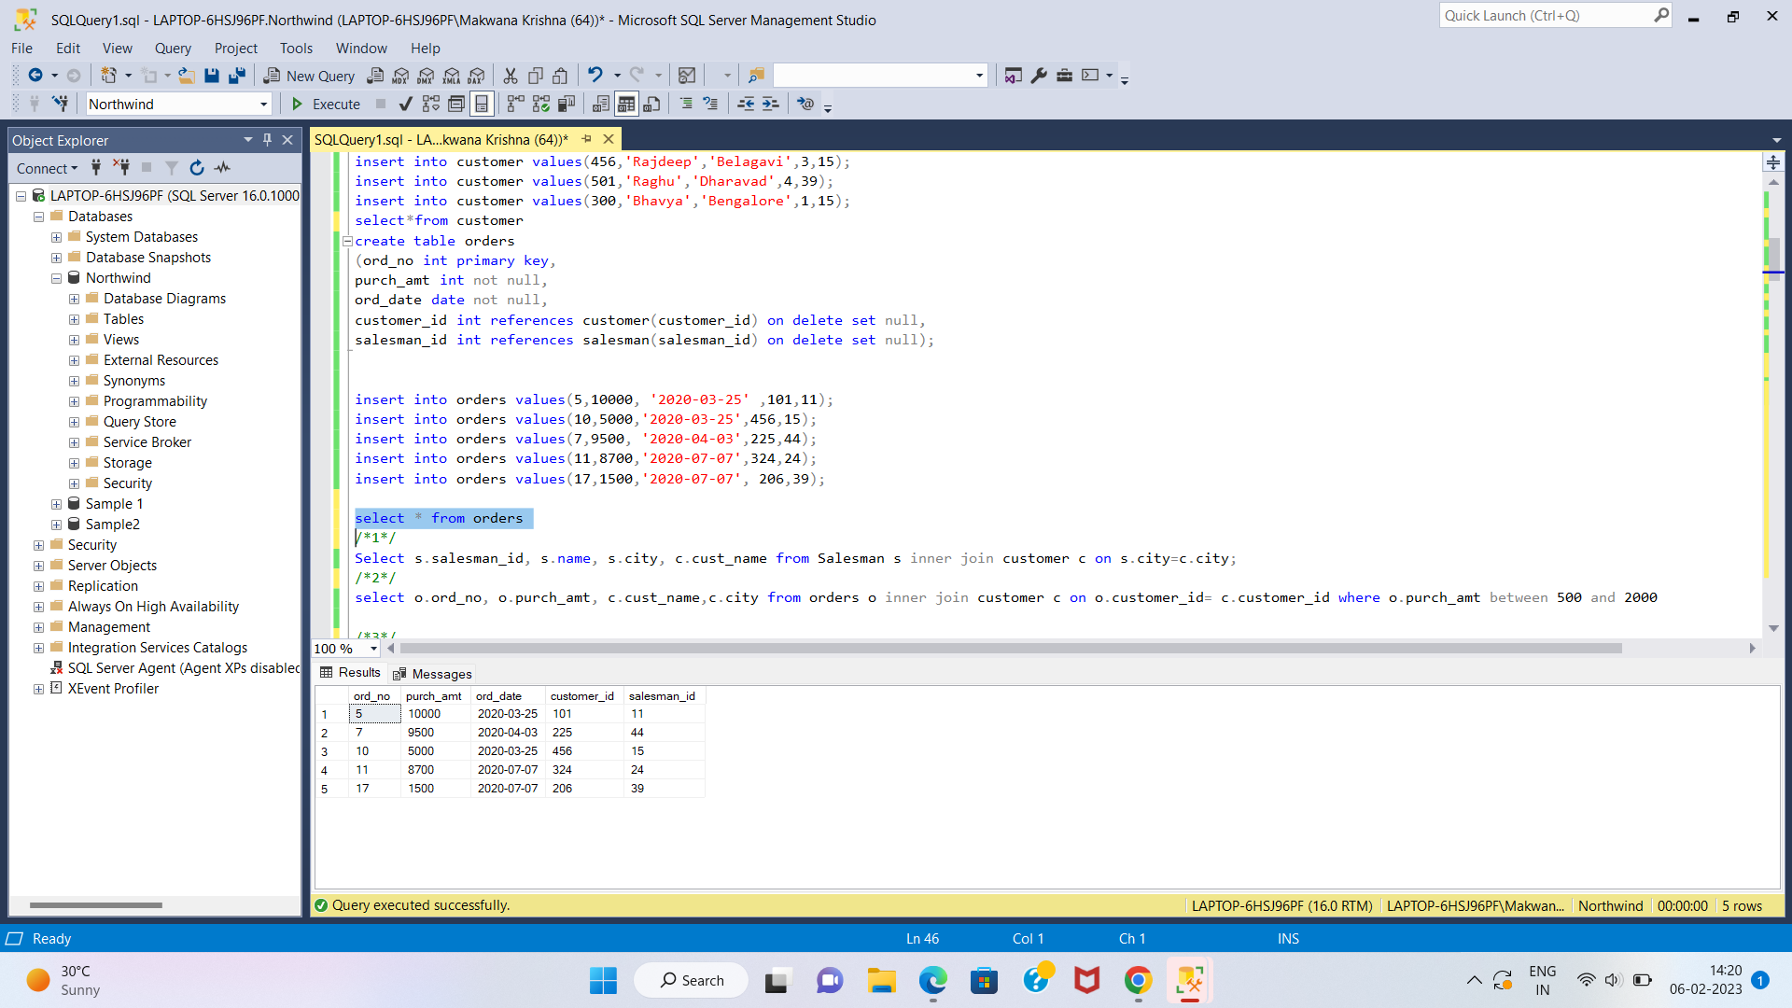

**1. write a SQL query to find the salesperson and customer who reside in the same city. Return Salesman, cust_name and city**

**Ans.** select name,cust_name,c_city

from salesman s

inner join customer c

on S.salesman_id = C.salesman_id

where s_city = c_city;

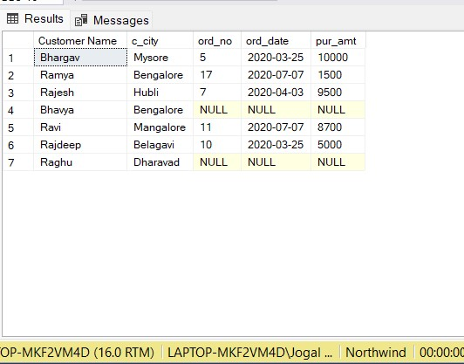

**2. write a SQL query to find those orders where the order amount exists between 500 and 2000. Return ord_no, purch_amt, cust_name, city**

**Ans.**

select ord_no,pur_amt,cust_name,c_city

from customer C

left JOIN orders O

on C.salesman_id = O.salesman_id

where O.pur_amt between 500 and 2000

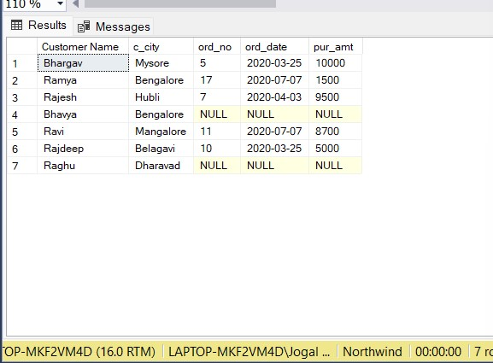

**3. write a SQL query to find the salesperson(s) and the customer(s) he represents. Return Customer Name, city, Salesman, commission**

**Ans.**

SELECT cust_name,c_city,name,commission

FROM customer c

INNER JOIN salesman s

ON c.salesman_id = s.salesman_id;

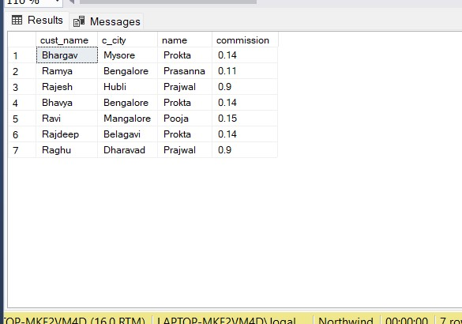

**4. write a SQL query to find salespeople who received commissions of more than 12 percent from the company. Return Customer Name, customer city, Salesman , commission.**

**Ans.**

select cust_name,c_city,name,commission

from salesman S

inner join customer C

on S.salesman_id = C.salesman_id

where commission>0.12

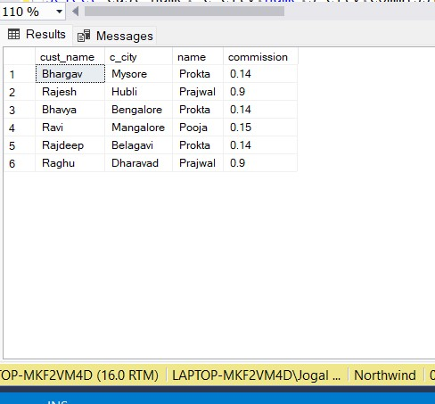

**5. write a SQL query to locate those salespeople who do not live in the same city where their customers live and have received a commission of more than 12% from the company. Return Customer Name, customer city, Salesman, salesman city, commission**

**Ans.**

select cust_name, c_city,name,s_city,commission

from salesman S

inner join customer C

on S.salesman_id = C.salesman_id

where s_city != c_city and commission>0.12

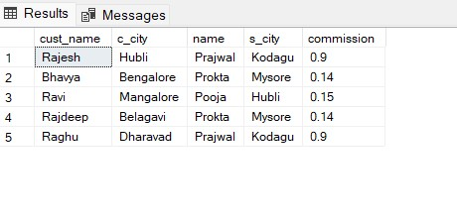

**6. write a SQL query to find the details of an order. Return ord_no, ord_date,**

**purch_amt, Customer Name, grade, Salesman, commission**

**Ans**.

select ord_no,ord_date,pur_amt,cust_name,grade,name,commission

from customer C

inner join orders O

on C.customer_id=O.customer_id

inner join salesman S

on C.salesman_id=S.salesman_id

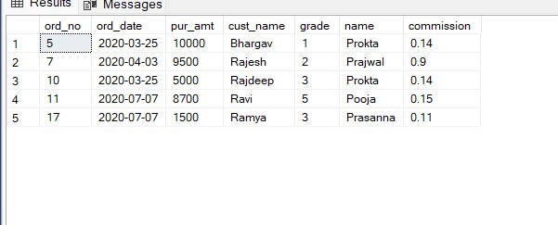

**7. Write a SQL statement to join the tables salesman, customer and orders so that the** **same column of each table appears once and only the relational rows are returned.**

**Ans.**

select *

from customer C

left join orders O

on C.customer_id=O.customer_id

left join salesman S

on C.salesman_id=S.salesman_id

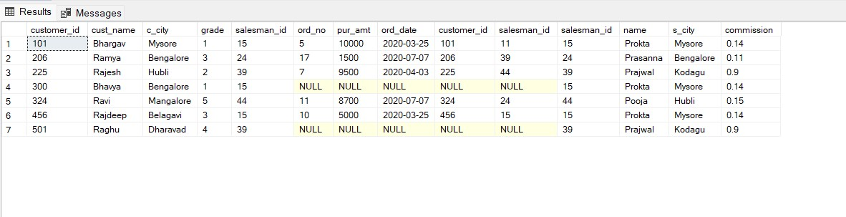

**8. write a SQL query to display the customer name, customer city, grade, salesman,**

**salesman city. The results should be sorted by ascending customer_id.**

**Ans.**

select cust_name as customername,

c_city as customercity,

grade,name as salesman,

s_city as salesmancity

from salesman S

inner join customer C

on S.salesman_id = C.salesman_id

order by customer_id

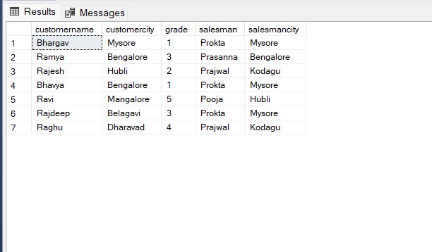

**9. write a SQL query to find those customers with a grade less than 300. Return cust_name, customer city, grade, Salesman, salesmancity. The result should be ordered by ascending customer_id.**

**Ans.**

select cust_name as cust_name,

c_city as customercity,

grade,name as salesman,

s_city as salesmancity

from salesman S

inner join customer C

on S.salesman_id = C.salesman_id

where grade<300

order by customer_id

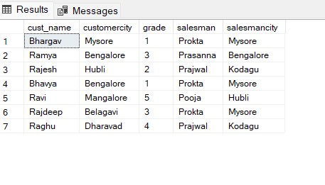

**10. Write a SQL statement to make a report with customer name, city, order number, order date, and order amount in ascending order according to the order date to determine whether any of the existing customers have placed an order or not**

**Ans.**

select cust_name as customer_name,

c_city as city,

ord_no as order_number,

ord_date as order_date,

pur_amt as order_amount

from customer C

LEFT OUTER join orders O

on C.customer_id = O.customer_id

order by ord_date

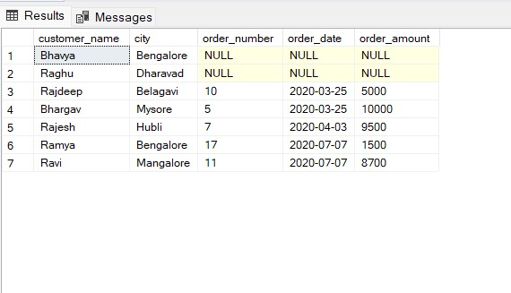

**11. Write a SQL statement to generate a report with customer name, city, order number, order date, order amount, salesperson name, and commission to determine if any of the existing customers have not placed orders or if they have placed orders through their salesman or by themselves**

**Ans.**

SELECT c.cust_name AS "Customer Name",

c.c_city,

o.ord_no,

o.ord_date,

o.pur_amt,

s.name AS "Salesman",

s.commission

FROM customer c

LEFT OUTER JOIN orders o

ON c.customer_id=o.customer_id

LEFT OUTER JOIN salesman s

ON c.salesman_id=s.salesman_id;

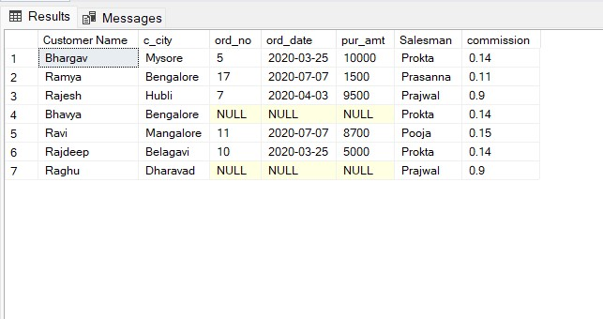

**12. Write a SQL statement to generate a list in ascending order of salespersons who work either for one or more customers or have not yet joined any of the customers**

**Ans.**

SELECT s.name AS "Salesman"

FROM salesman s

LEFT OUTER JOIN customer c

ON s.salesman_id=c.salesman_id

ORDER BY c.salesman_id ASC;

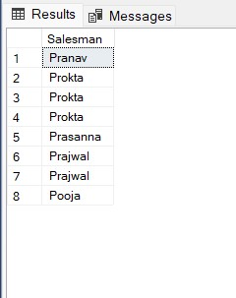

**13.write a SQL query to list all salespersons along with customer name, city, grade, order number, date, and amount.**

**Ans.**

select s.name as "salespersons",

cust_name as "customer name",

c_city as "city",

grade,

ord_no as "order number",

ord_date as "date",

pur_amt as "amount"

from salesman s

left join customer c

on s.salesman_id = c.salesman_id

left join orders o

on c.customer_id = o.customer_id

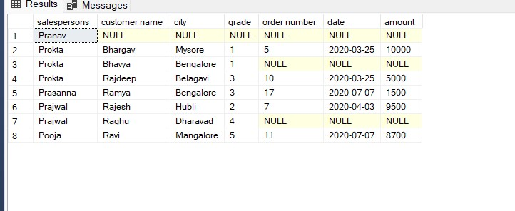

**14. Write a SQL statement to make a list for the salesmen who either work for one or more customers or yet to join any of the customers. The customer may have placed, either one or more orders on or above order amount 2000 and must have a grade, or he may not have placed any order to the associated supplier.**

**Ans.**

select name as "salespermen"

from salesman s

right join customer c

on s.salesman_id = c.salesman_id

right join orders o

on c.customer_id = o.customer_id

where pur_amt>2000 and grade is not null or o.salesman_id is null

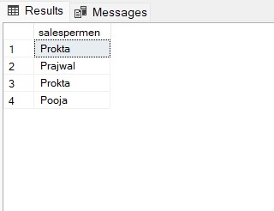**15. Write a SQL statement to generate a list of all the salesmen who either work for one or more customers or have yet to join any of them. The customer may have placed one or more orders at or above order amount 2000, and must have a grade, or he may not have placed any orders to the associated supplier.**



**16. Write a SQL statement to generate a report with the customer name, city, order no. order date, purchase amount for only those customers on the list who must have a grade and placed one or more orders or which order(s) have been placed by the customer who neither is on the list nor has a grade.**

**Ans.**

SELECT c.cust_name AS "Customer Name",

c.c_city,

o.ord_no,

o.ord_date,

o.pur_amt

FROM customer c

FULL OUTER JOIN orders o

ON c.customer_id= o.customer_id

AND c.grade IS NOT NULL;

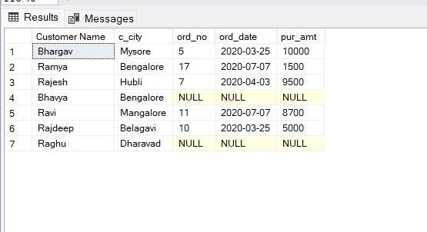

**17. Write a SQL query to combine each row of the salesman table with each row of the customer table**

**Ans.**

SELECT *

FROM salesman s

CROSS JOIN customer c;

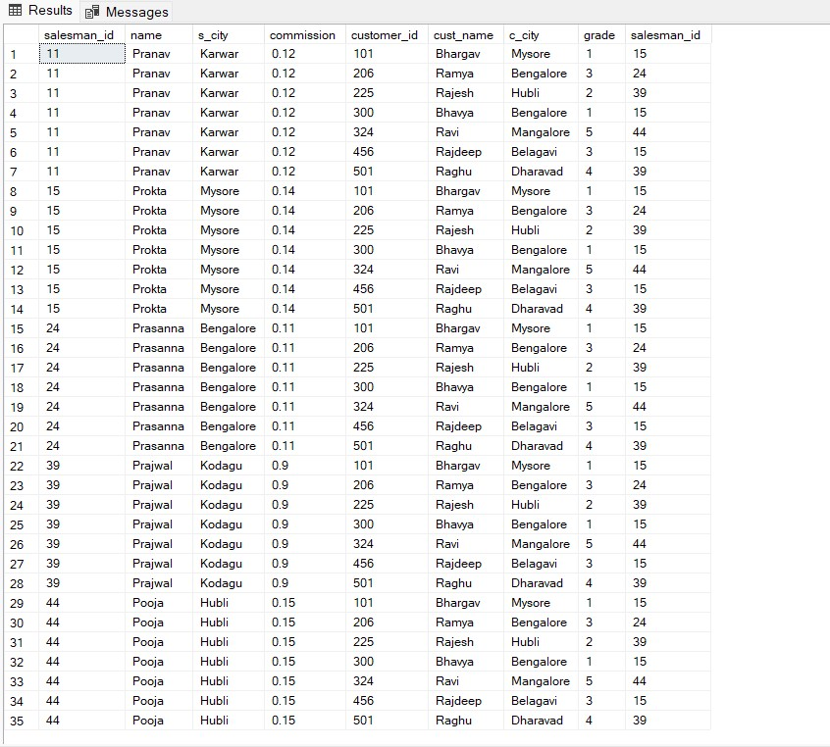

**18. Write a SQL statement to create a Cartesian product between salesperson and customer, i.e. each salesperson will appear for all customers and vice versa for that salesperson who belongs to that city**

**Ans.**

SELECT name as "salesperson",

cust_name as "customer"

FROM salesman s

CROSS JOIN customer c

where s_city = c_city

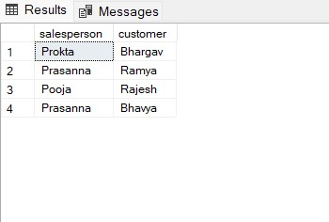

**19. Write a SQL statement to create a Cartesian product between salesperson and customer, i.e. each salesperson will appear for every customer and vice versa for those salesmen who belong to a city and customers who require a grade**

**Ans.**

SELECT name as "salesperson",

cust_name as "customer"

FROM salesman s

CROSS JOIN customer c

where s_city is not null and grade is not null

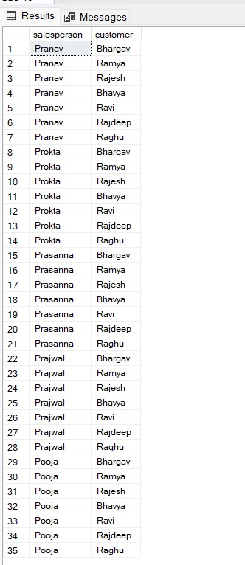

**20. Write a SQL statement to make a Cartesian product between salesman and**

**customer i.e. each salesman will appear for all customers and vice versa for those salesmen who must belong to a city which is not the same as his customer and the customers should have their own grade**

Ans.

SELECT name as "salesperson",

cust_name as "customer"

FROM salesman s

CROSS JOIN customer c

where s_city != c_city and grade is not null

